3. Functions

A function is a group of statements that exist within a program for the purpose of performing a specific task.
When using functions in a program, you generally isolate each task within the program in
its own function. For example, a realistic pay calculating program might have the following
functions:
• A function that gets the employee’s hourly pay rate
• A function that gets the number of hours worked
• A function that calculates the employee’s gross pay
• A function that calculates the overtime pay
• A function that calculates the withholdings for taxes and benefits
• A function that calculates the net pay
• A function that prints the paycheck
A program that has been written with each task in its own function is called a modularized
program.
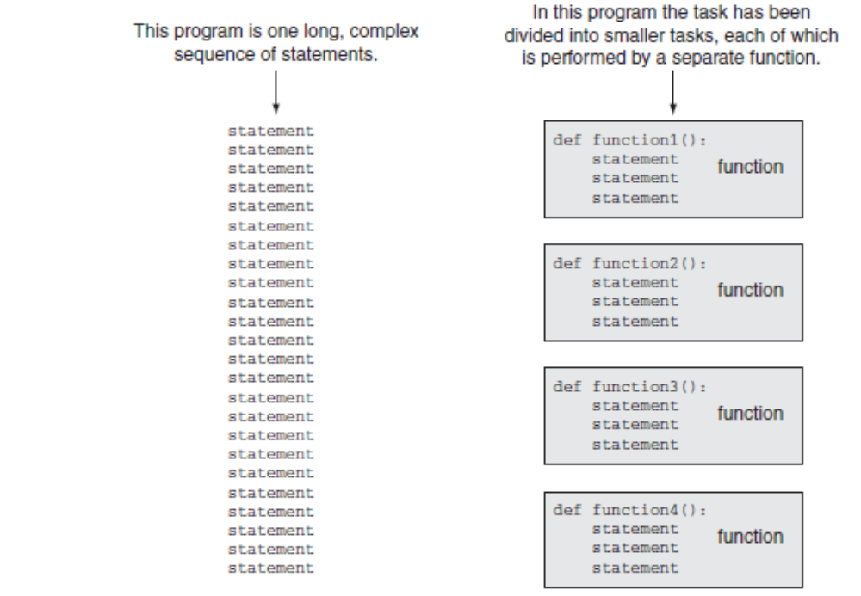
Benefits of Modularizing a Program with Functions
- Simpler Code
- Code Reuse
- Better Testing
- Faster Development
- Easier Facilitation of Teamwork

Defining and Calling a Function
The code for a function is known as a function definition. To execute the function, you write a statement that calls it.
To create a function you write its definition. Here is the general format of a function definition
in Python:
def function_name():
statement
statement
etc.

Calling a Function
function_name()

Program 3-1 (function_demo.py)
1 # This program demonstrates a function.
2 # First, we define a function named message.
3 def message():
4 print('I am Arthur,')
5 print('King of the Britons.')
6
7 # Call the message function.
8 message()

Indentation in Python
In Python, each line in a block must be indented. As shown in Figure 3-1, the last indented
line after a function header is the last line in the function’s block.

Variable scope : global & local variables

Algorithm Workbench

1. Write a function named times_ten. The function should accept an argument and display the product of its argument multiplied times 10.
2. Examine the following function header, and then write a statement that calls the function, passing 12 as an argument.
def show_value(quantity):
3. Look at the following function header:
def my_function(a, b, c):
Now look at the following call to my_function:
my_function(3, 2, 1)
When this call executes, what value will be assigned to a? What value will be assigned to b? What value will be assigned to c?
4. What will the following program display?
def main():
x = 1
y = 3.4
print(x, y)
change_us(x, y)
print(x, y)
def change_us(a, b):
a = 0
b = 0
print(a, b)
main()
5. Look at the following function definition:
def my_function(a, b, c):
d = (a + c) / b
print(d)
a. Write a statement that calls this function and uses keyword arguments to pass 2 into
a, 4 into b, and 6 into c.
b. What value will be displayed when the function call executes?

Programming Exercises

1. Kilometer Converter
Write a program that asks the user to enter a distance in kilometers, and then converts that distance to miles. The conversion formula is as follows:
Miles = Kilometers x 0.6214
2. Sale Tax Program Refactoring
Programming Exercise #6 in Chapter 2 was the Sales Tax program. For that exercise you were asked to write a program that calculates and displays the county and state sales tax on a purchase. If you have already written that program, redesign it so the subtasks are in functions. If you have not lready written that program, write it using functions.
3. How Much Insurance?
Many financial experts advise that property owners should insure their homes or buildings for at least 80 percent of the amount it would cost to replace the structure. Write a program that asks the user to enter the replacement cost of a building and then displays the minimum amount of insurance he or she should buy for the property.
4. Automobile Costs
Write a program that asks the user to enter the monthly costs for the following expenses incurred from operating his or her automobile: loan payment, insurance, gas, oil, tires, and maintenance. The program should then display the total monthly cost of these expenses, and the total annual cost of hese expenses.
5. Property Tax
A county collects property taxes on the assessment value of property, which is 60 percent of the property’s actual value. For example, if an acre of land is valued at $10,000, its assessment value is $6,000. The property tax is then 64￠ for each $100 of the assessment value. The tax for the acre assessed at $6,000 will be $38.40. Write a program that asks for the actual value of a piece of roperty and displays the assessment value and property tax.
6. Body Mass Index
Write a program that calculates and displays a person’s body mass index (BMI). The BMI is often used to determine whether a person is overweight or underweight for his or her height. A person’s BMI is calculated with the following formula:
BMI = weight x 703 / height2
where weight is measured in pounds and height is measured in inches.
7. Calories from Fat and Carbohydrates
A nutritionist who works for a fitness club helps members by evaluating their diets. As part of her evaluation, she asks members for the number of fat grams and carbohydrate grams that they consumed in a day. Then, she calculates the number of calories that result from the fat, using the following formula:
calories from fat =fat grams x 9
Next, she calculates the number of calories that result from the carbohydrates, using the
following formula:
calories from carbs = carb grams x 4
The nutritionist asks you to write a program that will make these calculations.
8. Stadium Seating
There are three seating categories at a stadium. For a softball game, Class A seats cost $15, Class B seats cost $12, and Class C seats cost $9. Write a program that asks how many tickets for each class of seats were sold, and then displays the amount of income generated from ticket sales.
9. Paint Job Estimator
A painting company has determined that for every 115 square feet of wall space, one gallon of paint and eight hours of labor will be required. The company charges $20.00 per hour for labor. Write a program that asks the user to enter the square feet of wall space to be painted and the price of the paint per gallon. The program should display the following data:
• The number of gallons of paint required
• The hours of labor required
• The cost of the paint
• The labor charges
• The total cost of the paint job
10. Monthly Sales Tax
A retail company must file a monthly sales tax report listing the total sales for the month, and the amount of state and county sales tax collected. The state sales tax rate is 4 percent and the county sales tax rate is 2 percent. Write a program that asks the user to enter the total sales for the month. From this figure, the application should calculate and display the following:
• The amount of county sales tax
• The amount of state sales tax
• The total sales tax (county plus state)

